1. **Steps for creating a billing alarm notifications from the cloud watch console :-**
2. **First sing in to the aws console.**
3. **Make sure the region is set to U.S.East(N.virginia) this is the region where AWS Stores billing information.**
4. **Next in the upper left open the billing and cost management**
5. **Type cloud watch in the AWS management console search box and then click Cloudwatch.**
6. **In the Cloud watch console menu on the left under Alarms, click on billing.**

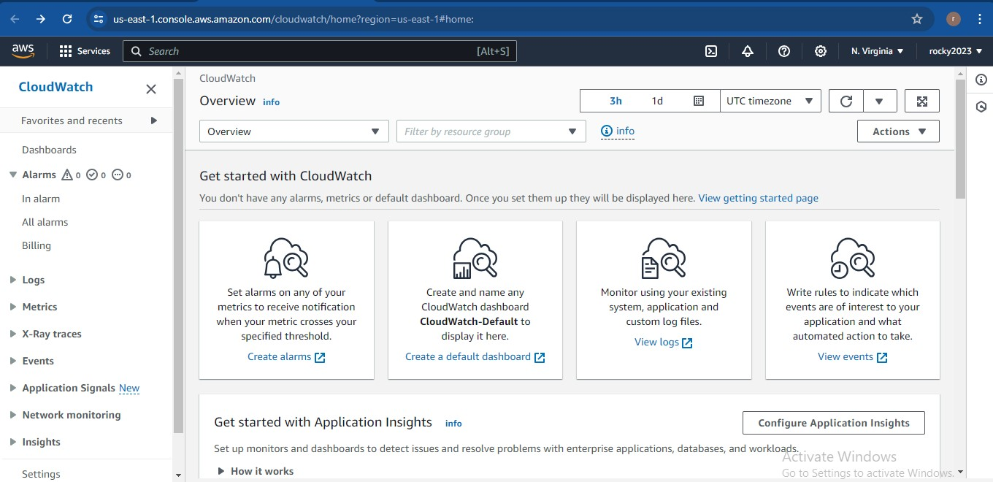

1. **In the billing alarms window, click the create alarm button.**
2. **Below image show to create alarm to click on that button.**

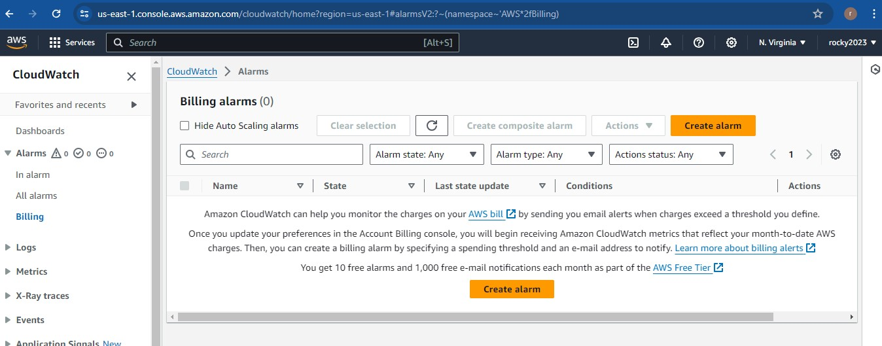

1. **Specify the metric and conditions by adding details in that given fields.**

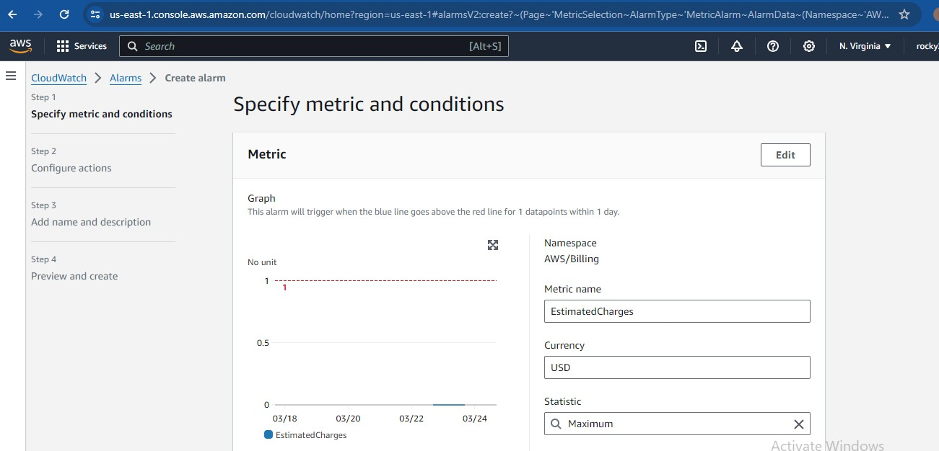

1. **Enter the threshold type as shown in below image add details in the given fields.**

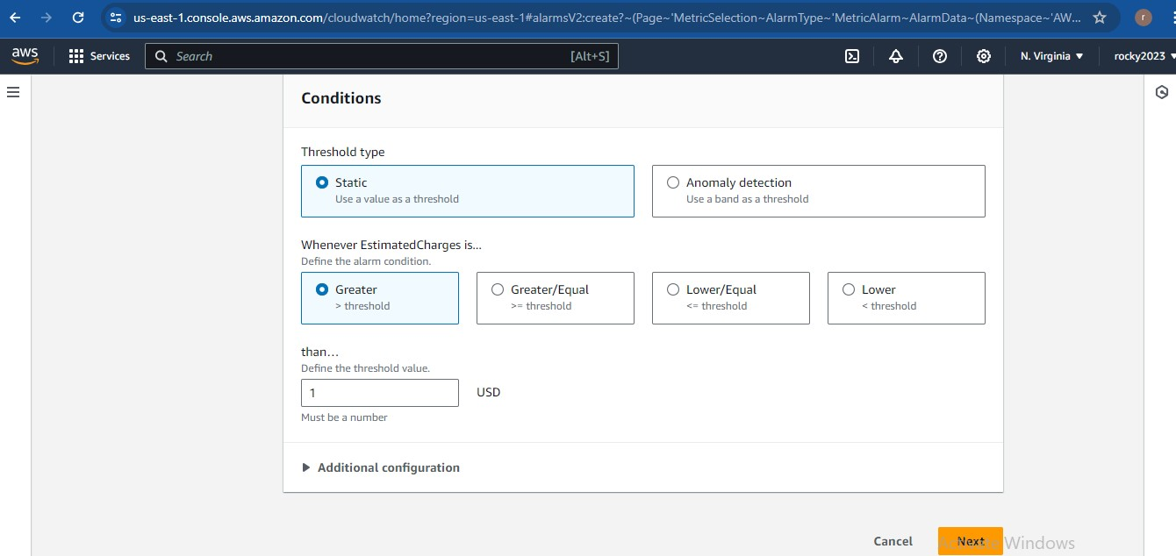

1. **Configure the actions like as shown in below page. Select the fields as shown in blue colour circle.**

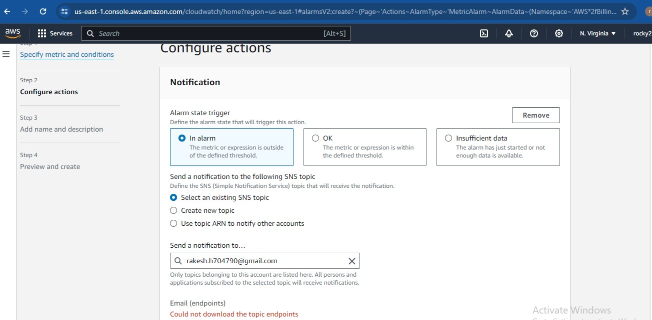

1. **Fallow the above steps as fallows.**

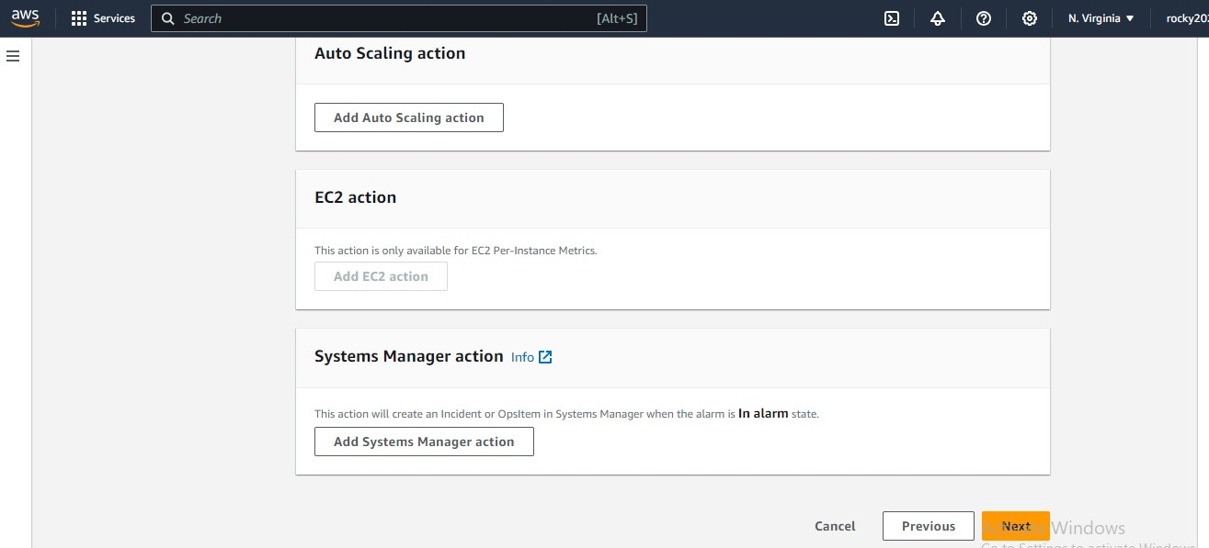

1. **Enter alarm name and description as shown in belpw image and click on next button after entering.**

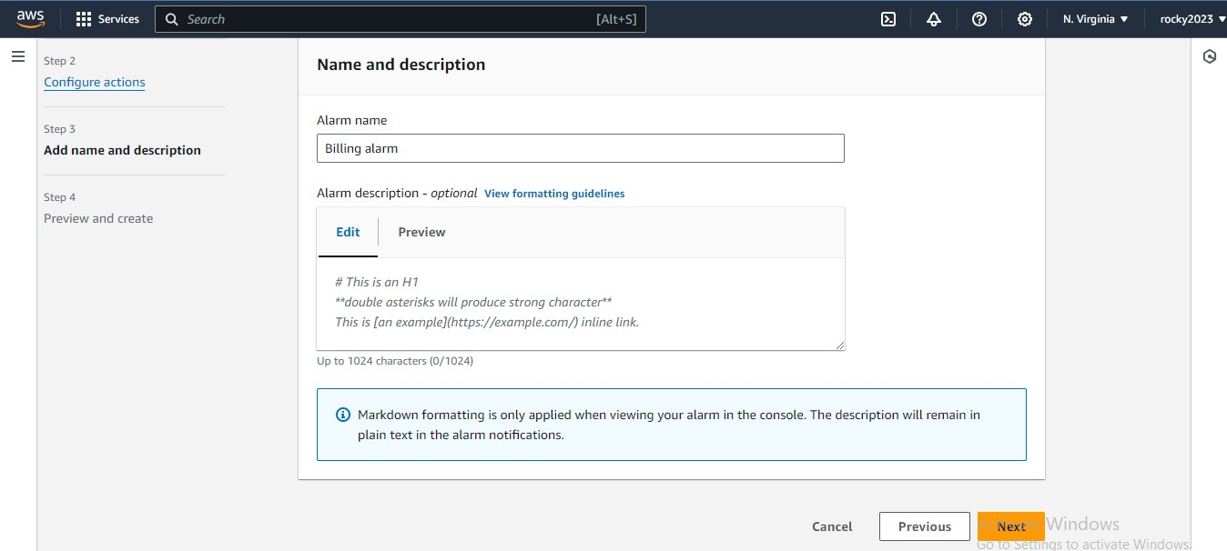

1. **Do preview and create the alarm.**

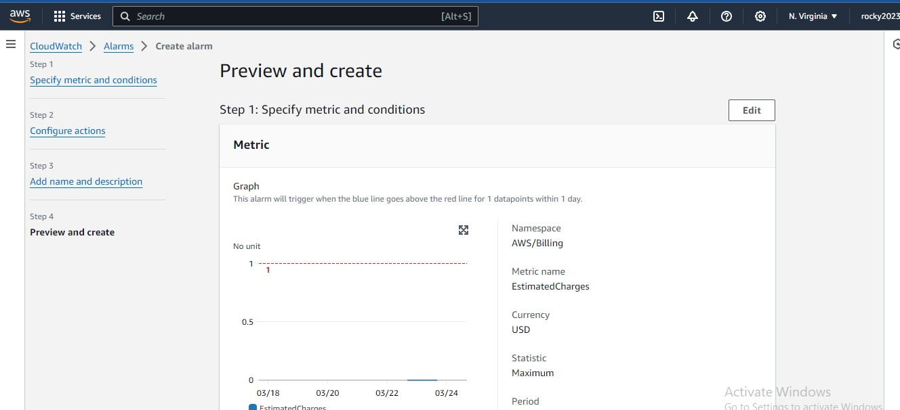

1. **Next finally step to create alarm.**

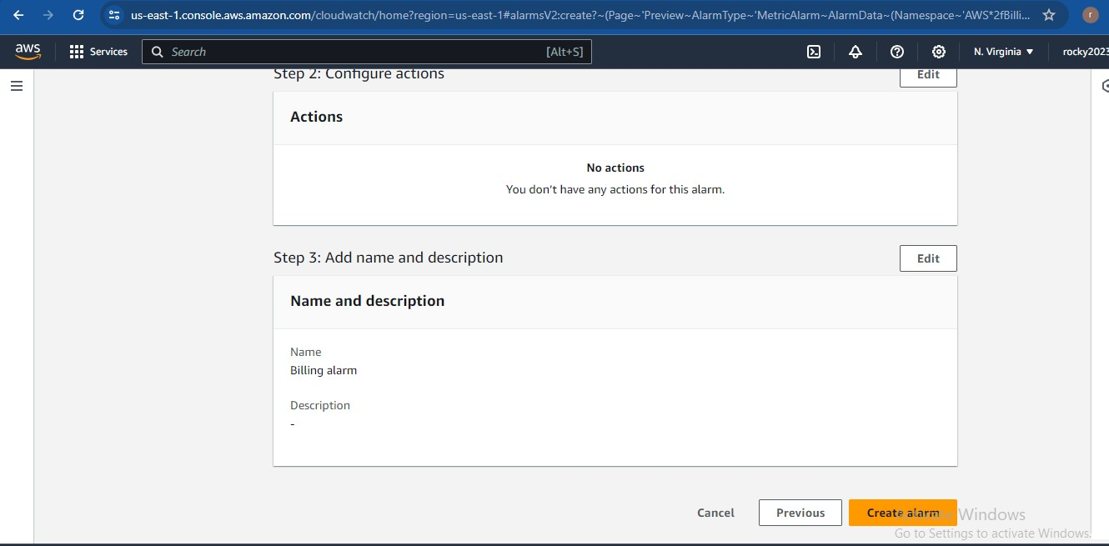

**10) Billin alarm created … as shown in below page…**

